

SRI LANKA INSTITUTE OF INFORMATION TECHNOLOGY

Enterprise Standards and Best Practices for IT Infrastructure4th Year 2nd Semester 2014

**4th Year 2nd Semester 2014**

Name: Dedigamuwa D.A.T.D.

SLIIT ID: IT13103378

Practical Session: WD Friday

Practical Number: Lab 4

* Step 01

Install VMware vSphere Client software and start it.

Provide the IP address of ESXi 5 host, the root username and password.

Click ‘Login’.

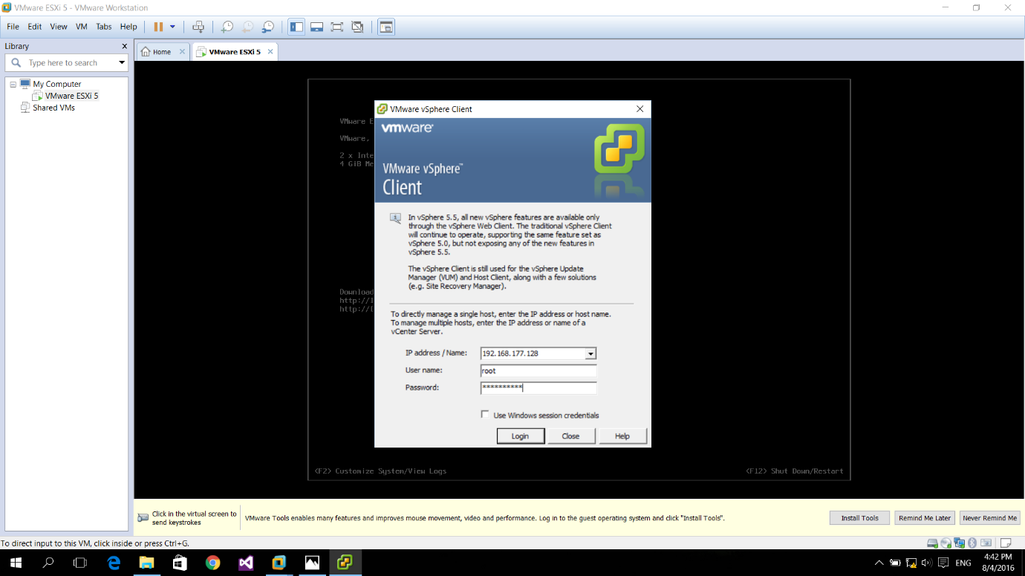

* Step 02

Ignore the SSL certificate security warning.

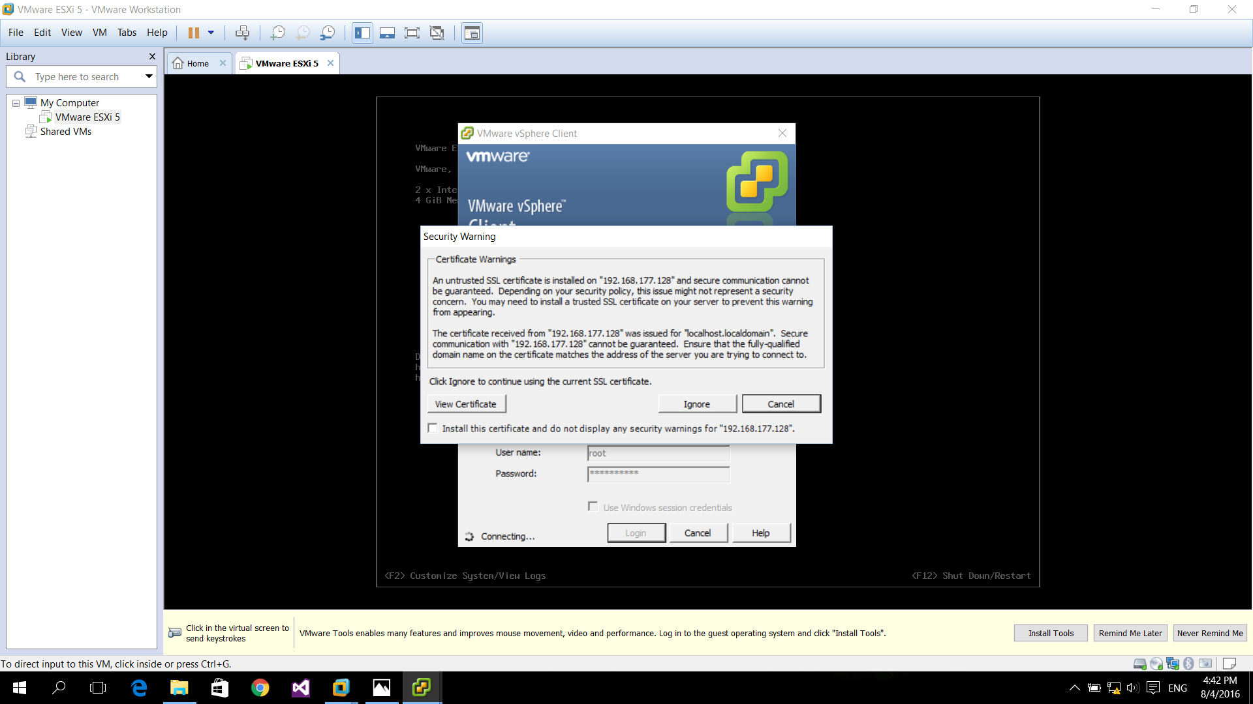

* Step 03

Go to the ‘Summary’ tab.

Right click on ‘datastore1’ from ‘Storage’ category and choose ‘Browse Datastore...’

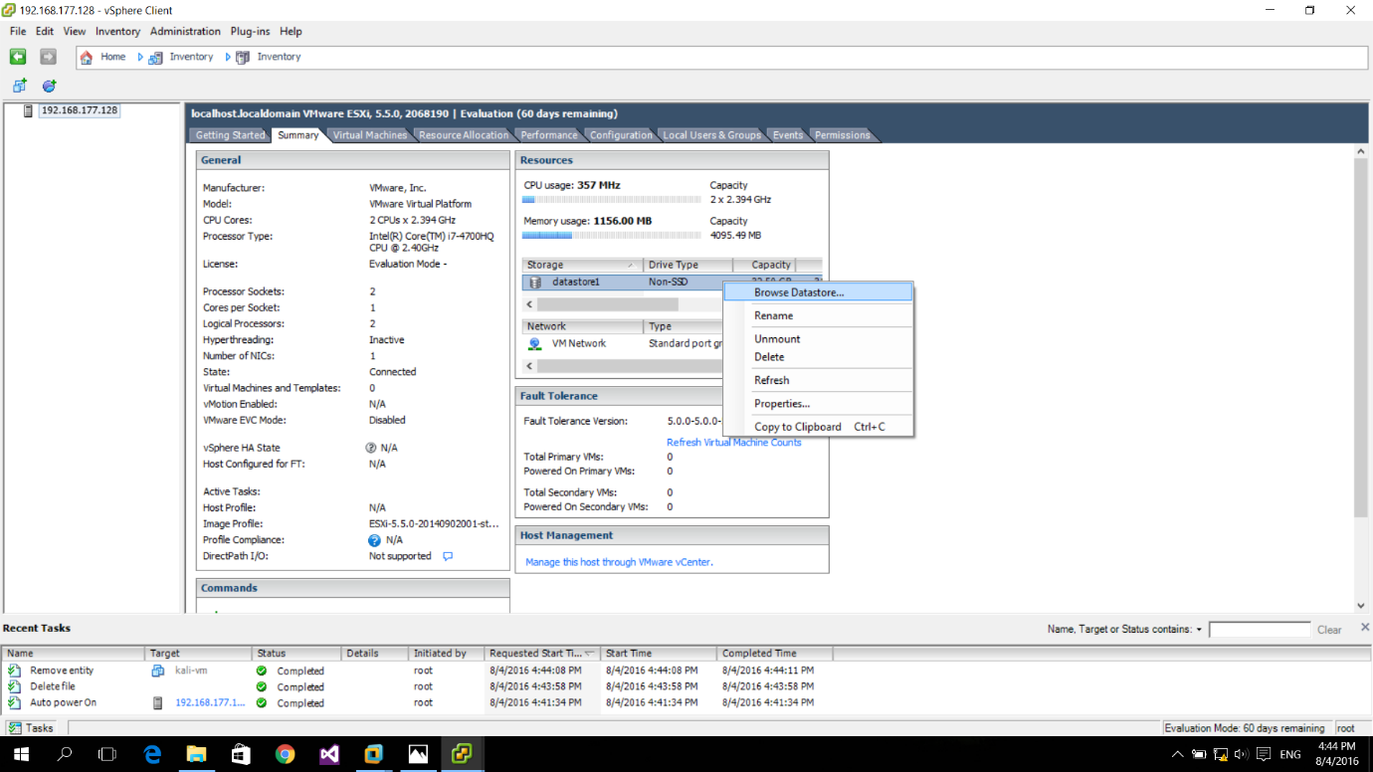

* Step 04

Choose ‘Upload File’ from ‘Upload files to this datastore’ icon.

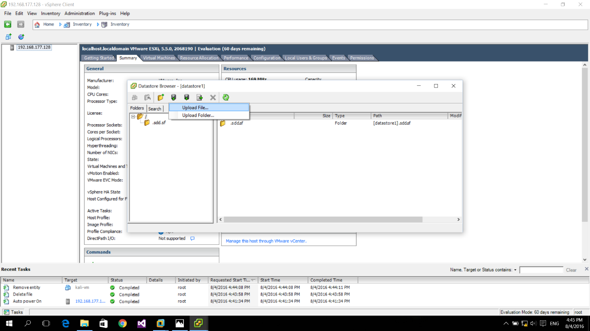

* Step 05

Browse for the ISO file of an OS and open it.

Then close the window after uploading is finished.

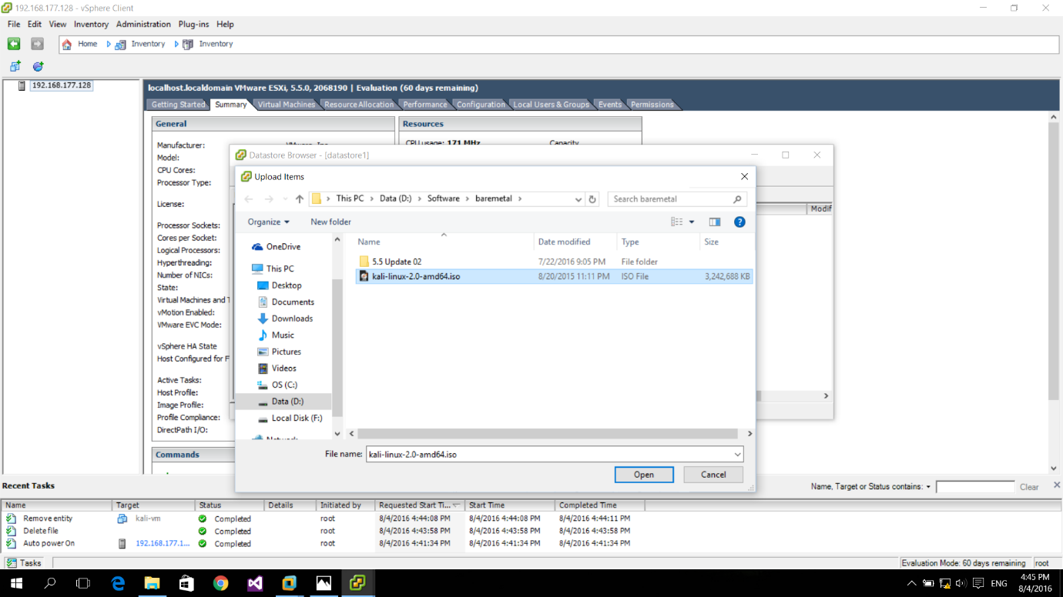

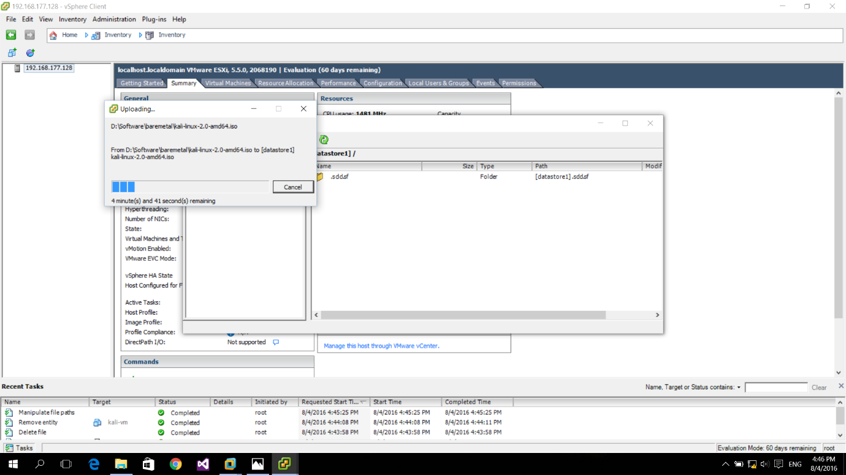

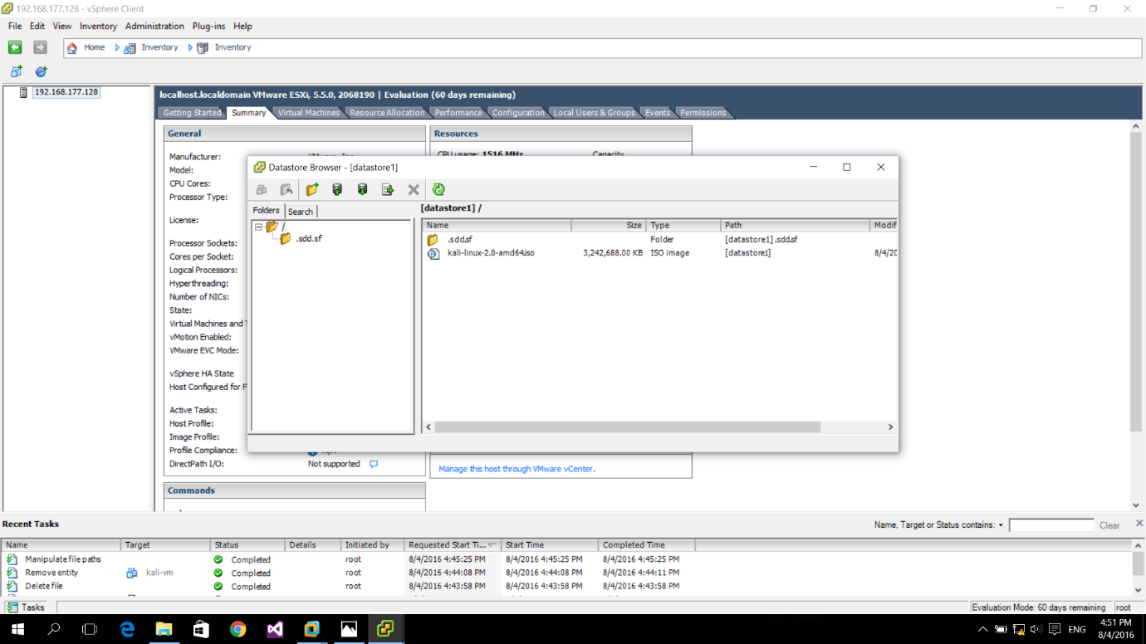

* Step 06

Right click on the host and choose ‘New Virtual Machine’.

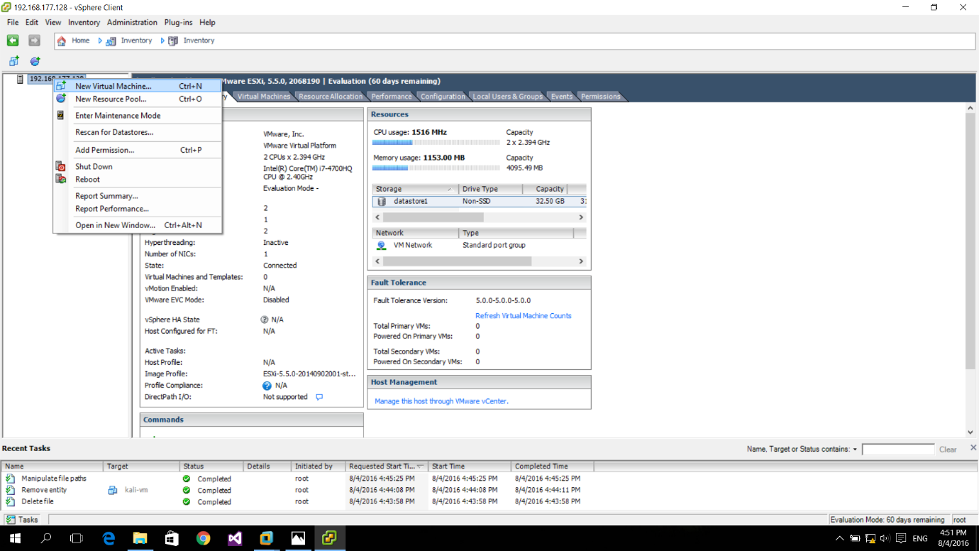

* Step 07

Select ‘Typical’ under ‘Configuration’ and click ‘Next’.

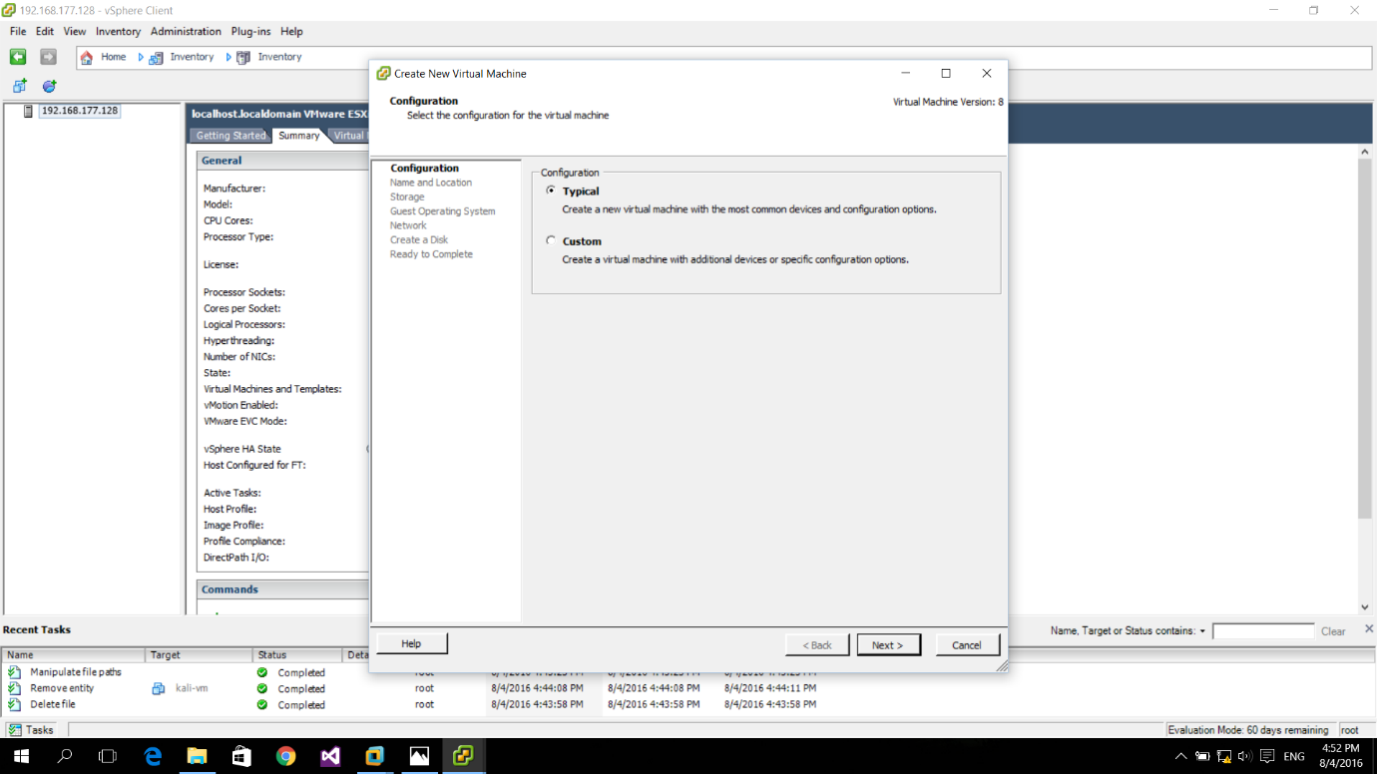

* Step 08

Provide a name for the virtual machine and click ‘Next’.

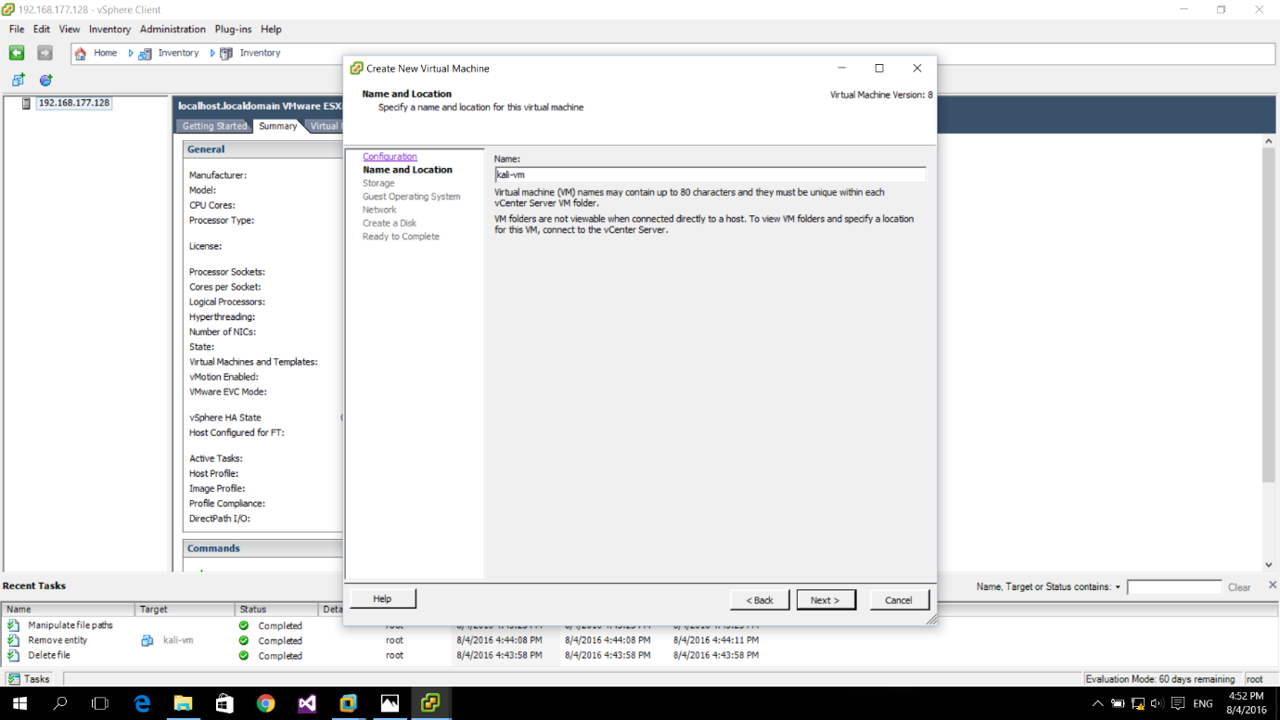

* Step 09

Click ‘Next’ on ‘Storage’ section.

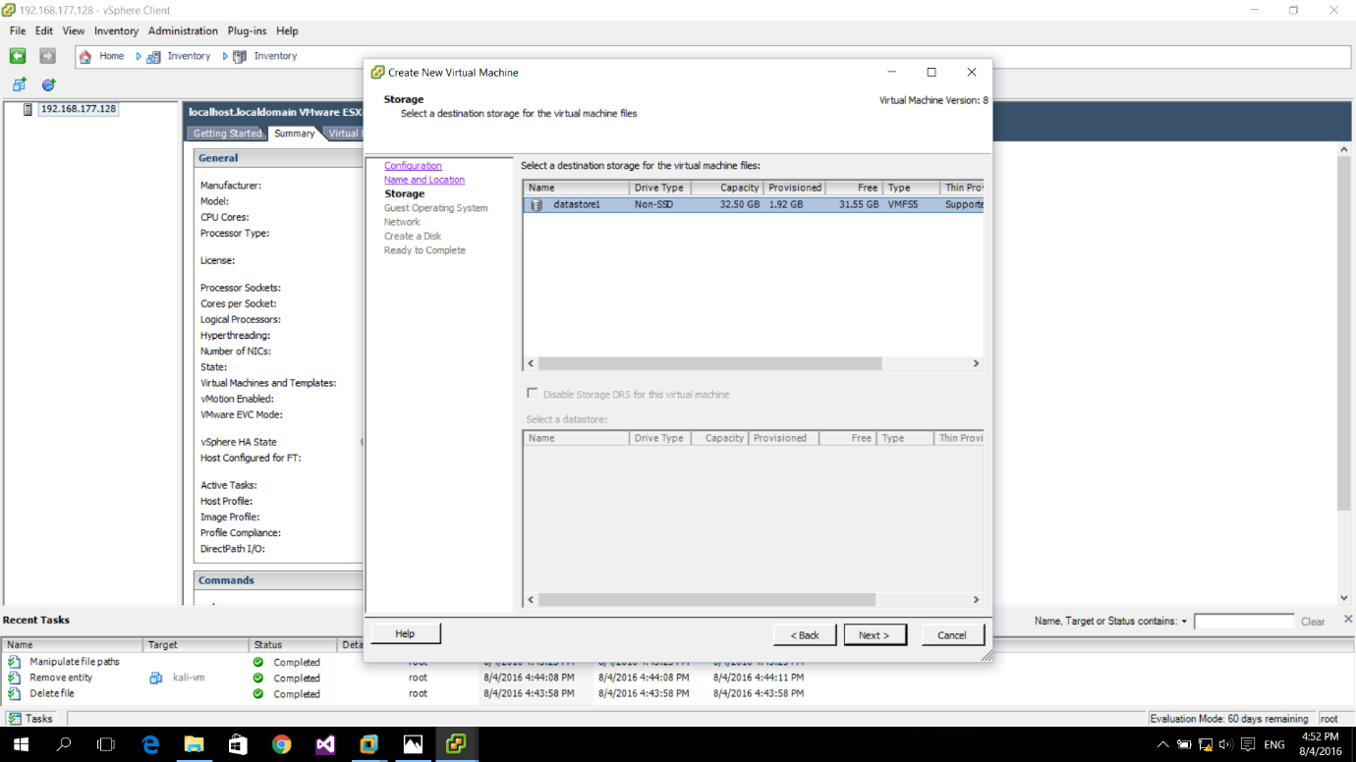

* Step 10

Select ‘Linux’ under ‘Guest Operating System’.

Choose ‘Other Linux (64-bit)’ and click ‘Next’.

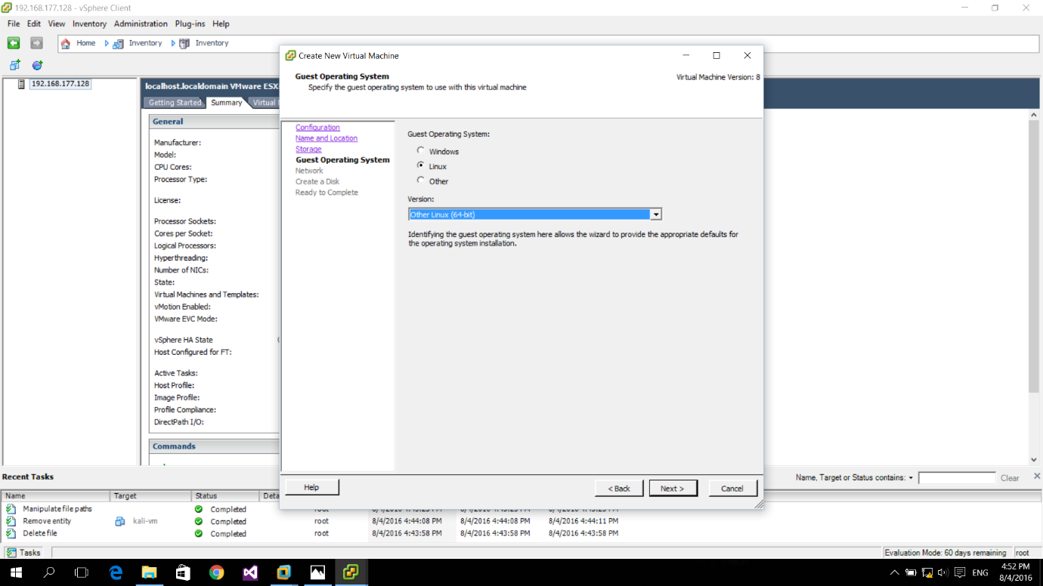

* Step 11

Click ‘Next’ on ‘Network’ section.

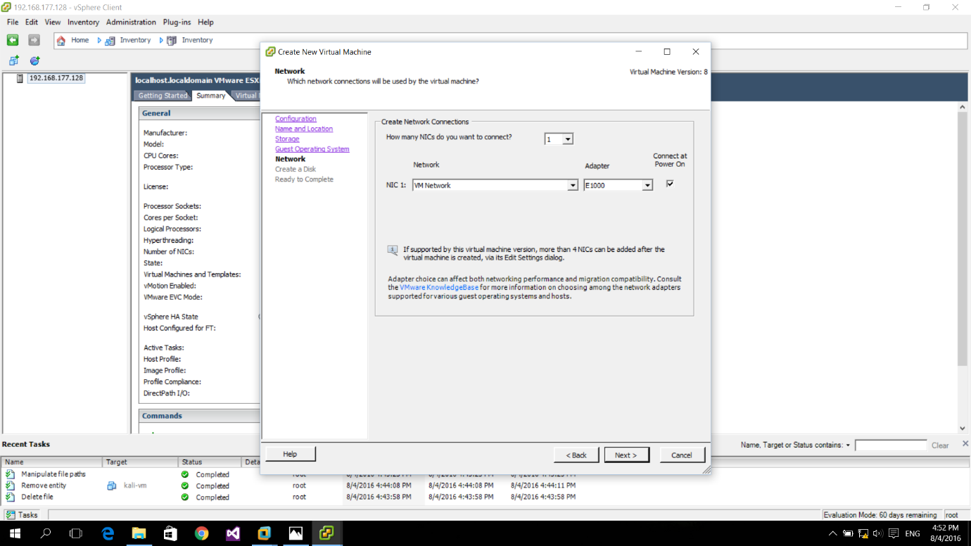

* Step 12

Select ‘Thin Provision’ on ‘Create a Disk’ section and click ‘Next’.

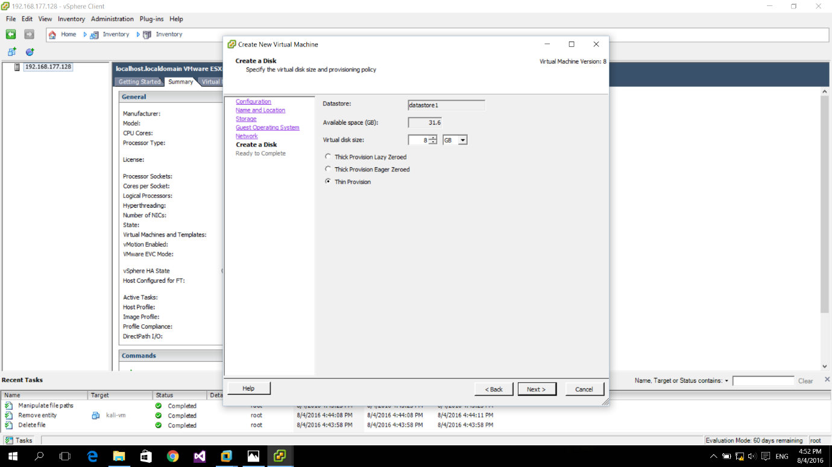

* Step 13

Click ‘Finish’.

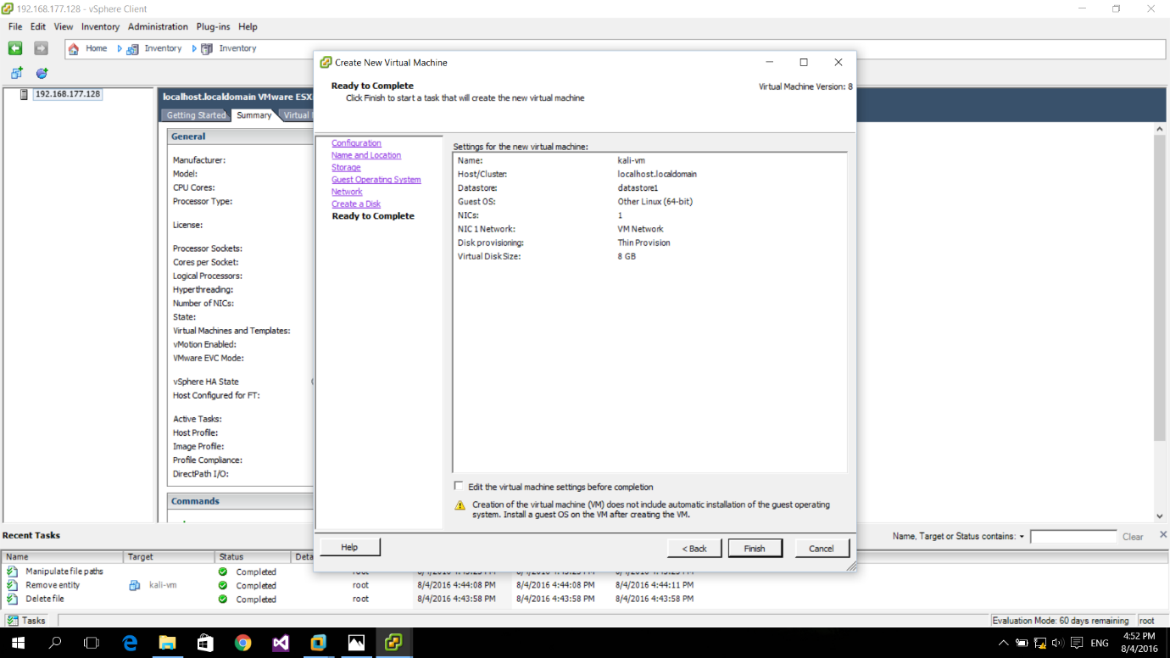

* Step 14

Right click on the created virtual machine and choose ‘Edit Settings...’

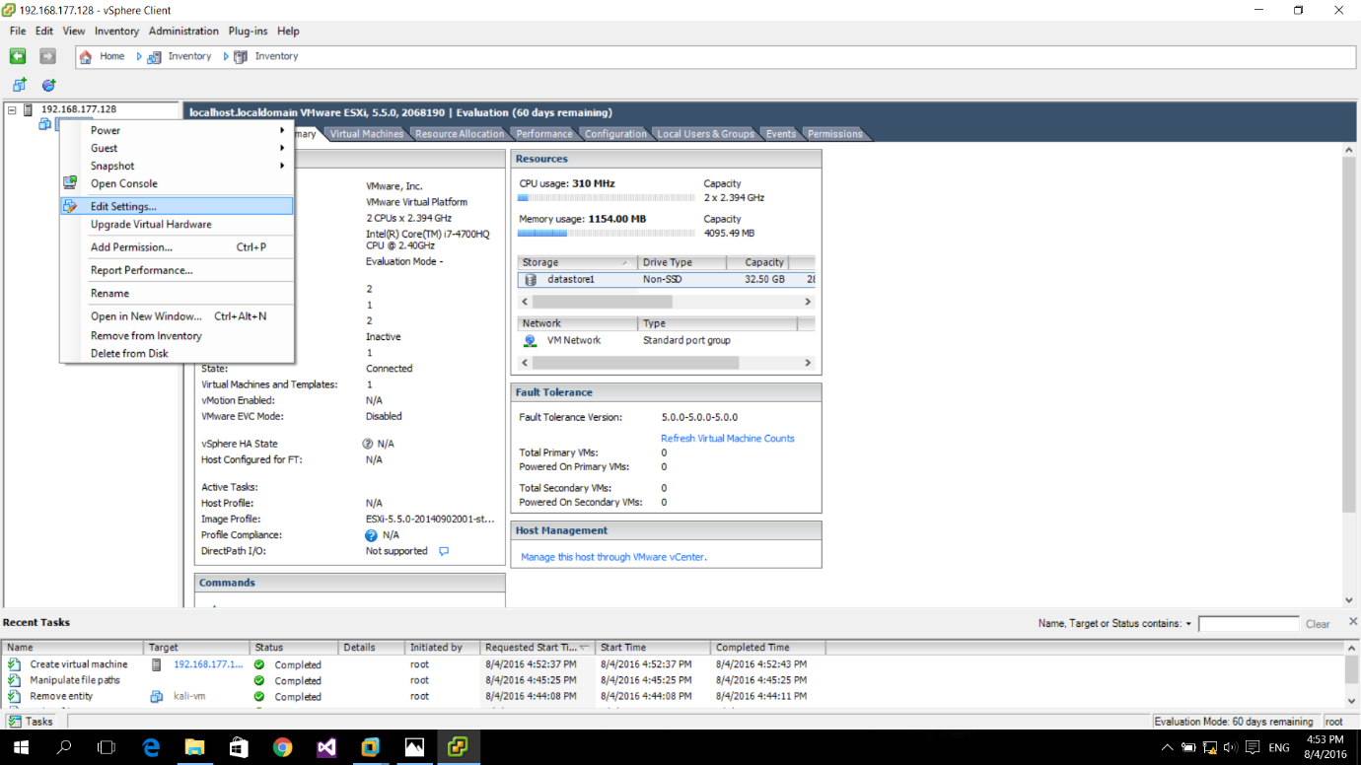

* Step 15

Change the memory size to 2048 MB.

Select ‘CD/DVD drive 1’ and choose ‘Datastore ISO File’.

Browse for the ISO file from the datastore.

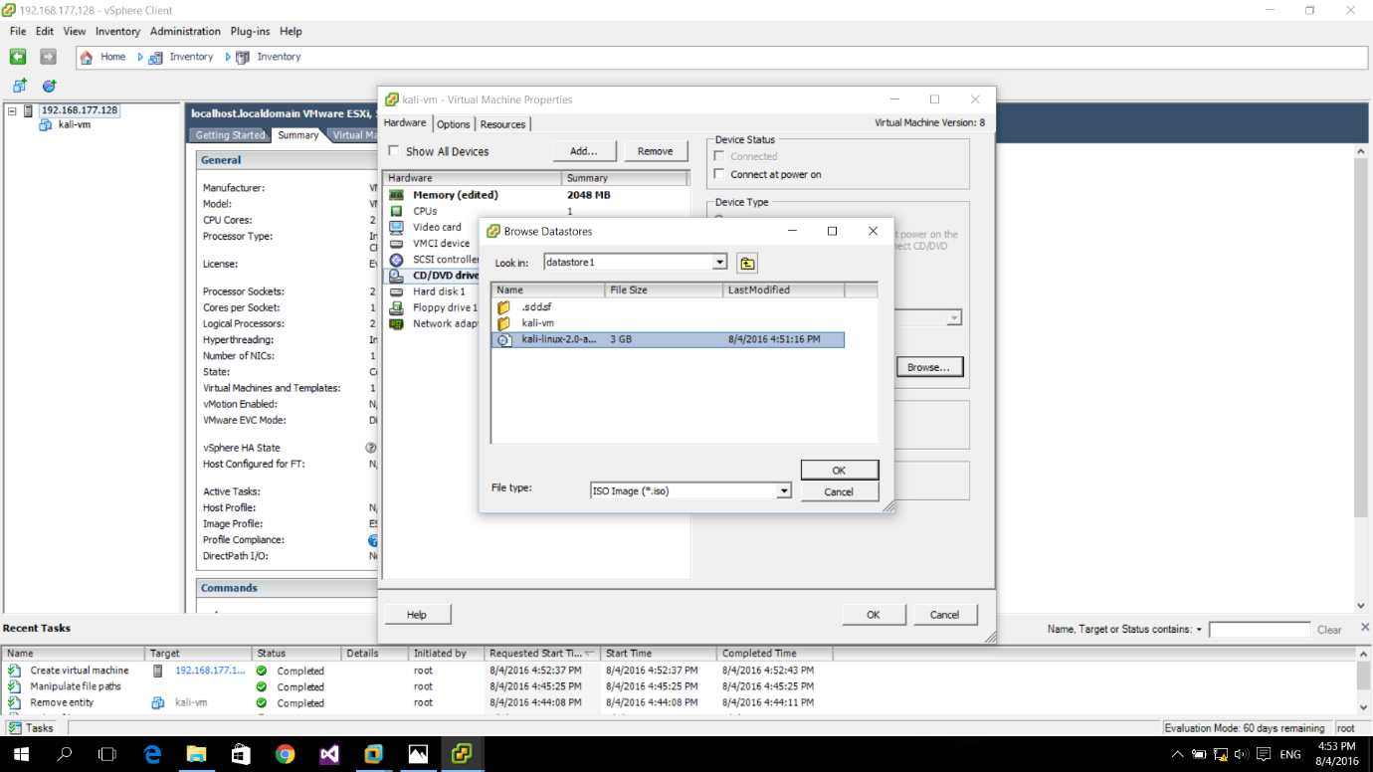

* Step 16

Select ‘Connect at power on’ from ‘Device Status’ and click ‘OK’.

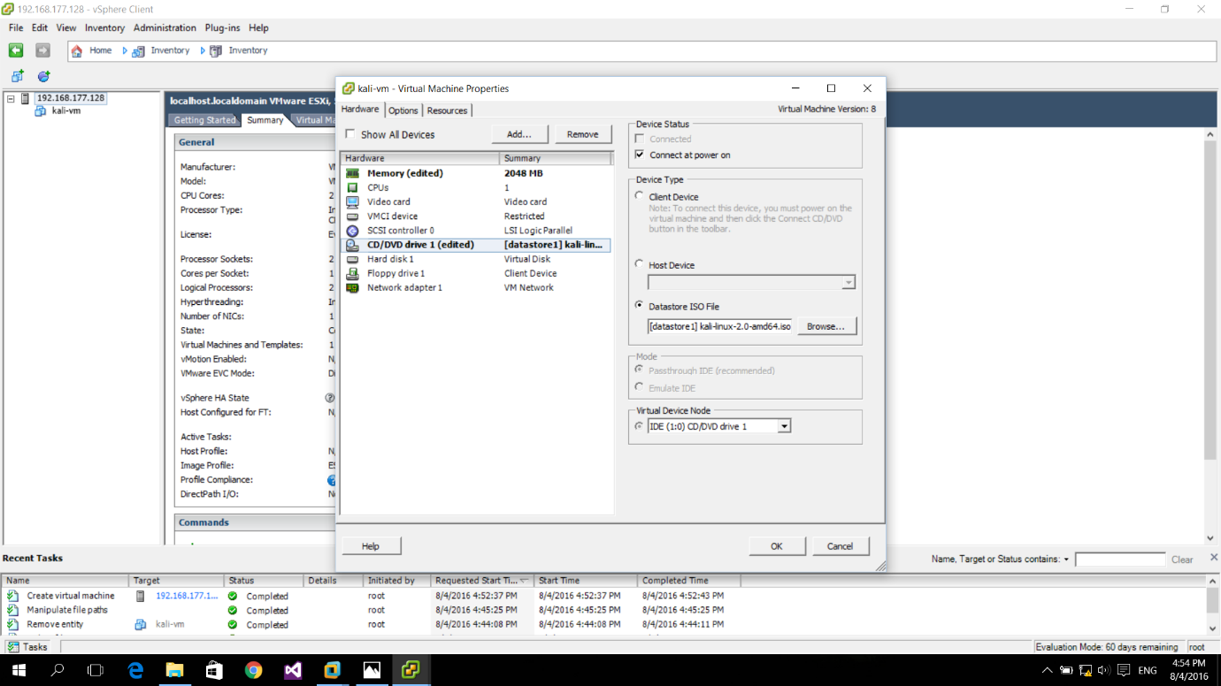

* Step 17

Go to the ‘Console’ tab and choose ‘Live (amd64)’.

Press ‘Enter’ to start installing ‘Kali’ on the created virtual machine.

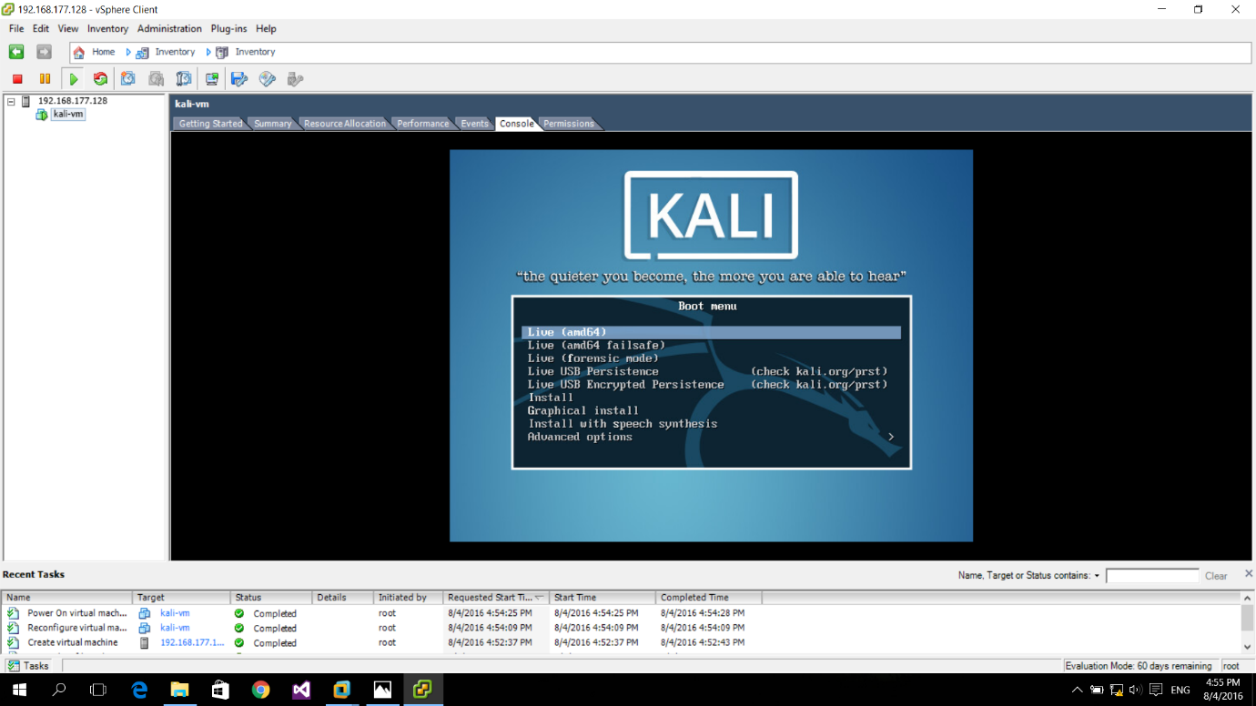

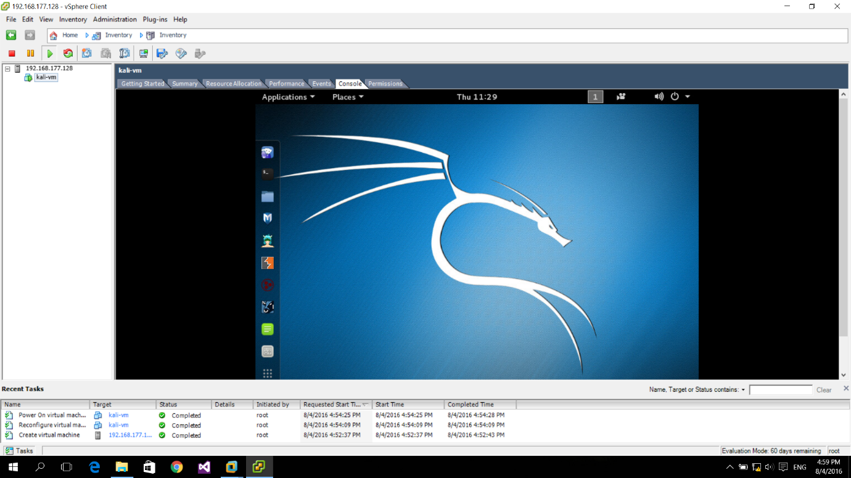

* Step 18

Open the terminal and type commands to check functioning.

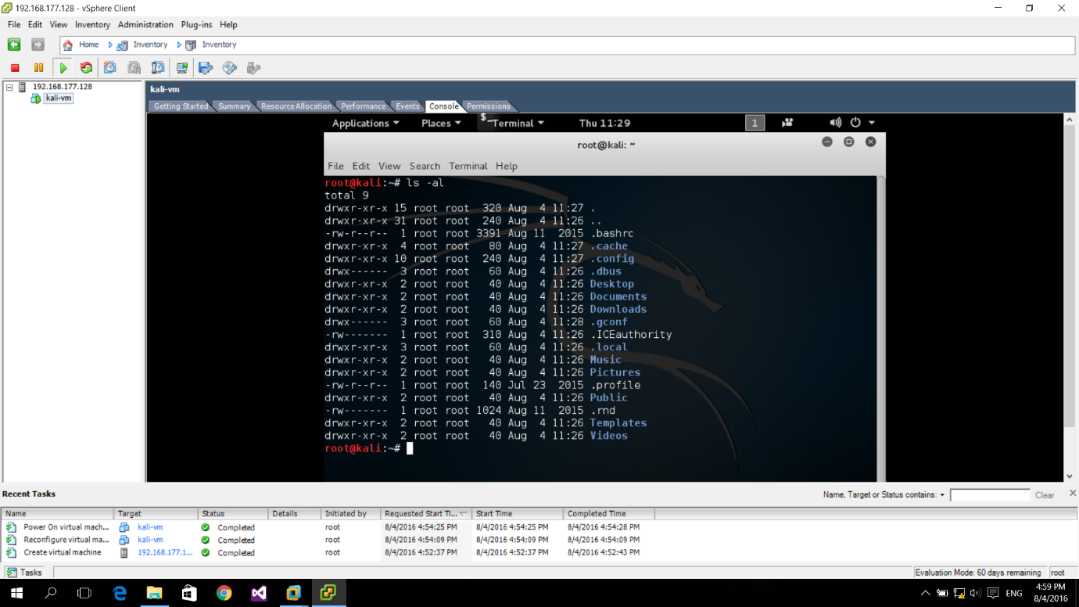

* Step 19

Power off ‘Kali’.

Shut Down ‘ESXi’.

